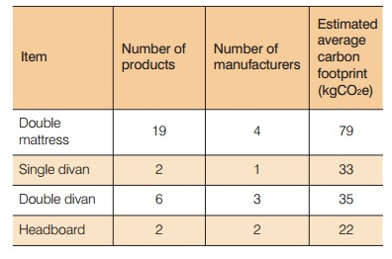

Source:

<https://www.fira.co.uk/document/fira-carbon-footprinting-document-2011.pdf>

pg 25